

The BEGINNING OF THE END OF THE COLD WAR

The Geneva Summit 1985

Gorbachev and A New Era in Soviet-American Relations

By Tyrus W. Cobb

Soviet-American relations were anything but warm during President Reagan’s first term in office. There were two primary reasons for this frosty and distant tie: First, Reagan did not want to deal with the USSR until he felt he had accomplished three objectives—(1) To rebuild the American military, which he felt had suffered through a period of unwarranted reductions and budget cuts during the Carter era; (2) To resuscitate the American economy, which when he took office was in a deep recession; and (3) To inculcate a sense of optimism and pride in America’s future, which he felt had too long been going in a negative and pessimistic direction.

Second, Reagan had tried to establish better communications with the Soviet leadership, but the aging, sclerotic General Secretaries in the Kremlin were incapable of taking the USSR into a new direction. When Reagan came into office, the Kremlin was led by the fading Leonid Brezhnev, whose drinking and lack of clarity of thinking were well known—and somewhat frightening. When he died in 1982, it appeared that Moscow would now turn to a younger, more dynamic leader. And when the KGB chief Yuri Andropov, known to be urbane (because he liked to drink Scotch and listen to American jazz!), was selected to head up the Politburo, it did seem like a new era had dawned. However, no sooner had Andropov become the General Secretary than he, too, became very ill and somewhat incapacitated, finally dying in 1984.

By the fourth year of that initial term, it appeared that the Soviets would certainly pick a younger, more dynamic leader, but once again the Politburo went in the opposite direction, anointing 84-year old Konstantin Chernenko! Perhaps this was regarded as an interim appointment, knowing that Chernenko was fading, something that was obvious to anyone watching the embarrassing appearances by Chernenko, when he literally had to be led to a podium to speak, which he did incoherently.

As anticipated, Chernenko lasted but a year, and with his death in March of 1985, the Soviet leadership once again faced a dilemma. The safe choice would be to select the aging and experienced Foreign Minister, Andrei Gromyko. By this time, however, the USSR’s severe economic failures were visible even to the old men in the Politburo, and they passed over Gromyko to select the young, innovative and relatively unknown Mikhail Gorbachev as the new General Secretary. It’s not certain what in Gorbachev the leadership saw—or hoped for—especially since his primary area of responsibility was the agriculture sector—certainly not a part of the economy noted for great successes!

Reagan felt confident that the timing now was right for a Summit meeting with his Soviet counterpart, which he had not had during his first four years in office! When the media would pester Reagan about why he had not met with a Soviet leader in his first term, he once replied, “Well I call them….but they keep dying on me!” He was coming off a resounding victory over Walter Mondale in the 1984 election, the American economy was responding well to Reagan’s tax cuts and financial stimuli, the U.S. military had been rebuilt, and there was a renewed sense of confidence in the country as his campaign slogan, “It’s Morning in America,” enshrined.

The American military did seem to be resuscitated. The successful invasion of Grenada in 1983 and the expulsion of the Cuban forces there provided a renewed sense of confidence. The U.S. was preparing to deploy its own theater-level missiles in West Europe to counter the SS-20’s the USSR had emplaced in East Europe. And, the President had launched what would be, if successful, a strategic breakthrough in the military balance: his SDI program.

To many observers, however, things weren’t going well—there was massive opposition in Europe to the proposed U.S. deployments of the Pershing II missiles and the GLCMs—ground-launched cruise missiles. And with respect to SDI, most of the scientific community and military leaders dismissed it as technically infeasible and as a very costly waste of scarce investment dollars.

The Soviet leadership, however, did not share the negative viewpoint of much of West Europe as well as that of many in the U.S. While Reagan’s deployments faced significant opposition and his SDI program appeared to be nothing more than a fanciful dream, the Kremlin believed he could successfully rebuild the US military, strengthen the NATO alliance, and, most importantly, develop a viable strategic defense. That belief, and the fact that the Soviet economy was continuing to weaken, impelled the Soviet leadership to seek agreements limiting the American military buildup, constraining SDI, and expanding trade in high technology items currently prohibited for export to the USSR.

Preparing for the Geneva Summit

Reagan and Gorbachev agreed to hold a Summit in Geneva, in November 1985. Well before that first meeting of the two most powerful leaders in the world, an extensive briefing process began to prepare the President on a range of issues likely to come up at the Summit. I was appointed to be the “Executive Secretary” for the summit preparation, which despite the impressive-sounding title, meant that I was in charge of assembling the briefing books, putting together the President’s background sessions for pre-summit meetings with outside experts, and insuring that Reagan had voluminous material to pore over in preparation for the historic conclave with Gorbachev.

Of course, for the bureaucracies, there was no limit to what the President had to know! Thus, background papers were prepared on arms control, trade relations, the Soviet economy, status of dissidents, Gorby’s personality, the team that the General Secretary was likely to bring with him to Geneva, and even what Gorbachev did as he rose through the Communist Party ranks (principally his experience overseeing key agricultural sectors). This necessitated a series of briefings, meetings with experts inside and outside of government, highly classified personality analyses by the CIA and other intelligence agencies, and the formulation of a definitive US stance on many issues hotly debated within a very divided U.S. national security community.

The material was overwhelming. Suddenly, just three weeks before the Summit, after months of these interminable meetings with the President, Reagan called a halt to all discussions and briefings. His advisors were perplexed, saying there were numerous topics yet to be covered in greater depth, from arms control to trade issues, to human rights. “But Mr. President, we still have to brief you on....”, well, you name it, it all was important to the bureaucracy that the President be steeped in the issues they deemed important.

The President turned to all of us and said persuasively, “I have been preparing for this meeting for 40 years…. And if I’m not ready now, I’m never going to be.”

Oval Office briefing for the President on the Geneva Summit with VP Bush, Secretary Shultz, National Security Advisor Bud McFarlane, and myself

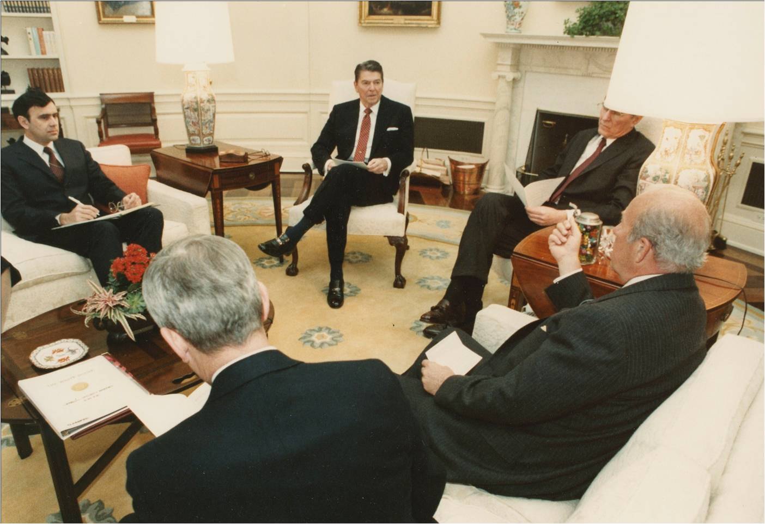
The President was right. Clearly Reagan did not need to be the master of every intricate detail of issues impacting the Soviet-U.S. relationship. Certainly President Carter had allowed himself to get so immersed in every detail of a topic that he often lost sight of the bigger picture. Reagan did the opposite; he would focus on what he considered to be important principles, while his advisors would debate the details of various agreements and issues with their Soviet counterparts.

Many “experts” doubted that Reagan was up to the task of dealing with Gorbachev, the dynamic, young and globally popular new Soviet leader, who took over the ruling Politburo in 1985 following years of decrepit rule by aging and sick (Brezhnev, Andropov, and Chernenko) leaders in Moscow. If the truth be known, many of the top officials in our own government were not so convinced that the President was ready to match wit and wisdom with Gorbachev.

Reagan’s Department of Defense seemed to be the leading “doubter”. During the preparations for the visit, the President would receive wildly contradictory advice from his principal advisors, primarily Secretaries Weinberger and Shultz. The increasingly acrimonious relationship between the two made it very difficult for the administration to reach agreement on key issues. As then National Security Advisor, Robert C. “Bud” McFarlane, observed, “While such rivalry (between the secretaries of State and Defense) exists in every administration, the rivalry between State and Defense was extreme, endemic, and ultimately corrosive” (McFarlane, Special Trust, p. 323). Bud notes that in meetings, Cap would run on endlessly, apparently trying to frustrate George, to the point that Schultz would resign.... and in that case Cap would become Secretary of State, “which in the last analysis is exactly what he wanted” (McFarlane, p. 324). On numerous occasions Shultz threatened to resign, but Reagan could not bear losing either of his top advisors. As a consequence, the acrimony increased in tone and frequency.

A particularly galling maneuver came on the eve of our departure for Geneva. The New York Times printed a letter sent by Cap to the President, urging him to “stand firm in Geneva”. According to McFarlane, the leak of the letter (which he notes landed on the front page of the Times almost before it got to the President!), “.... angered Reagan. He thought the leak unnecessary, a signal that someone didn’t think he could handle the account, and that he needed a public goading to keep him in line. It represented a lack of confidence in him and a breach in teamplay” (McFarlane, p. 317).

But the conflicts over policy were not just between cabinet officers, but within the Reagan White House as well. Secretary Shultz said the tensions within the administration were wearing heavily on McFarlane, “who was very morose and talked of quitting in the spring of 1985... worn down by incessant intra-white house squabbling, with Bud increasingly at odds with Chief of Staff Don Regan and Communications Director Pat Buchanan” (Shultz, p. 602).

With respect to the dispute over U.S. positions for the summit, none were more important than our stance on negotiations regarding our nuclear forces and weapons. On this score Reagan appeared not only to share Shultz’s views, but with respect to the role of nuclear arms, he went much further than either Cap or George were happy with. In particular, during our preparations and as we got closer to the Summit, Reagan would frequently go back to his deep held desire to eliminate all nuclear weapons from the face of the earth.

Reagan commented in his memoirs, “George Shultz and Cap Weinberger were having one of their disputes over policy. Cap was not as interested as George in pursuing negotiations with the Russians, and some of his advisors in the Pentagon strongly opposed some of my ideas on arms control that George supported, including my hope for eventually eliminating all nuclear weapons from the world”. Reagan said that Ed Meese and Bill Casey lined up with Cap “in favoring an even harder line toward the Russians” (Reagan, An American Life, p. 606).

I think it is very important to emphasize here that two aspects of our nuclear policy were central to the Reagan world view. First, as mentioned, a world free of nuclear weapons, and secondly, an impenetrable shield to defend against an incoming missile attack.

Early on in his administration Reagan received a briefing from the Pentagon regarding casualties that could be anticipated from a nuclear exchange between the USSR and the U.S. “I’ll never forget it”, the President wrote. “The Pentagon said that at least 150 million American lives would be lost in a nuclear war.... even if we ‘won’!”

“My dream then became a world free of nuclear weapons” (Reagan, p. 550). Reagan continued, “I had this second dream: the creation of a defense against nuclear missiles, so we could change from a policy of assured destruction to one of assured survival” (Reagan, p. 550).

Arrival at Reagan’s First Superpower Summit
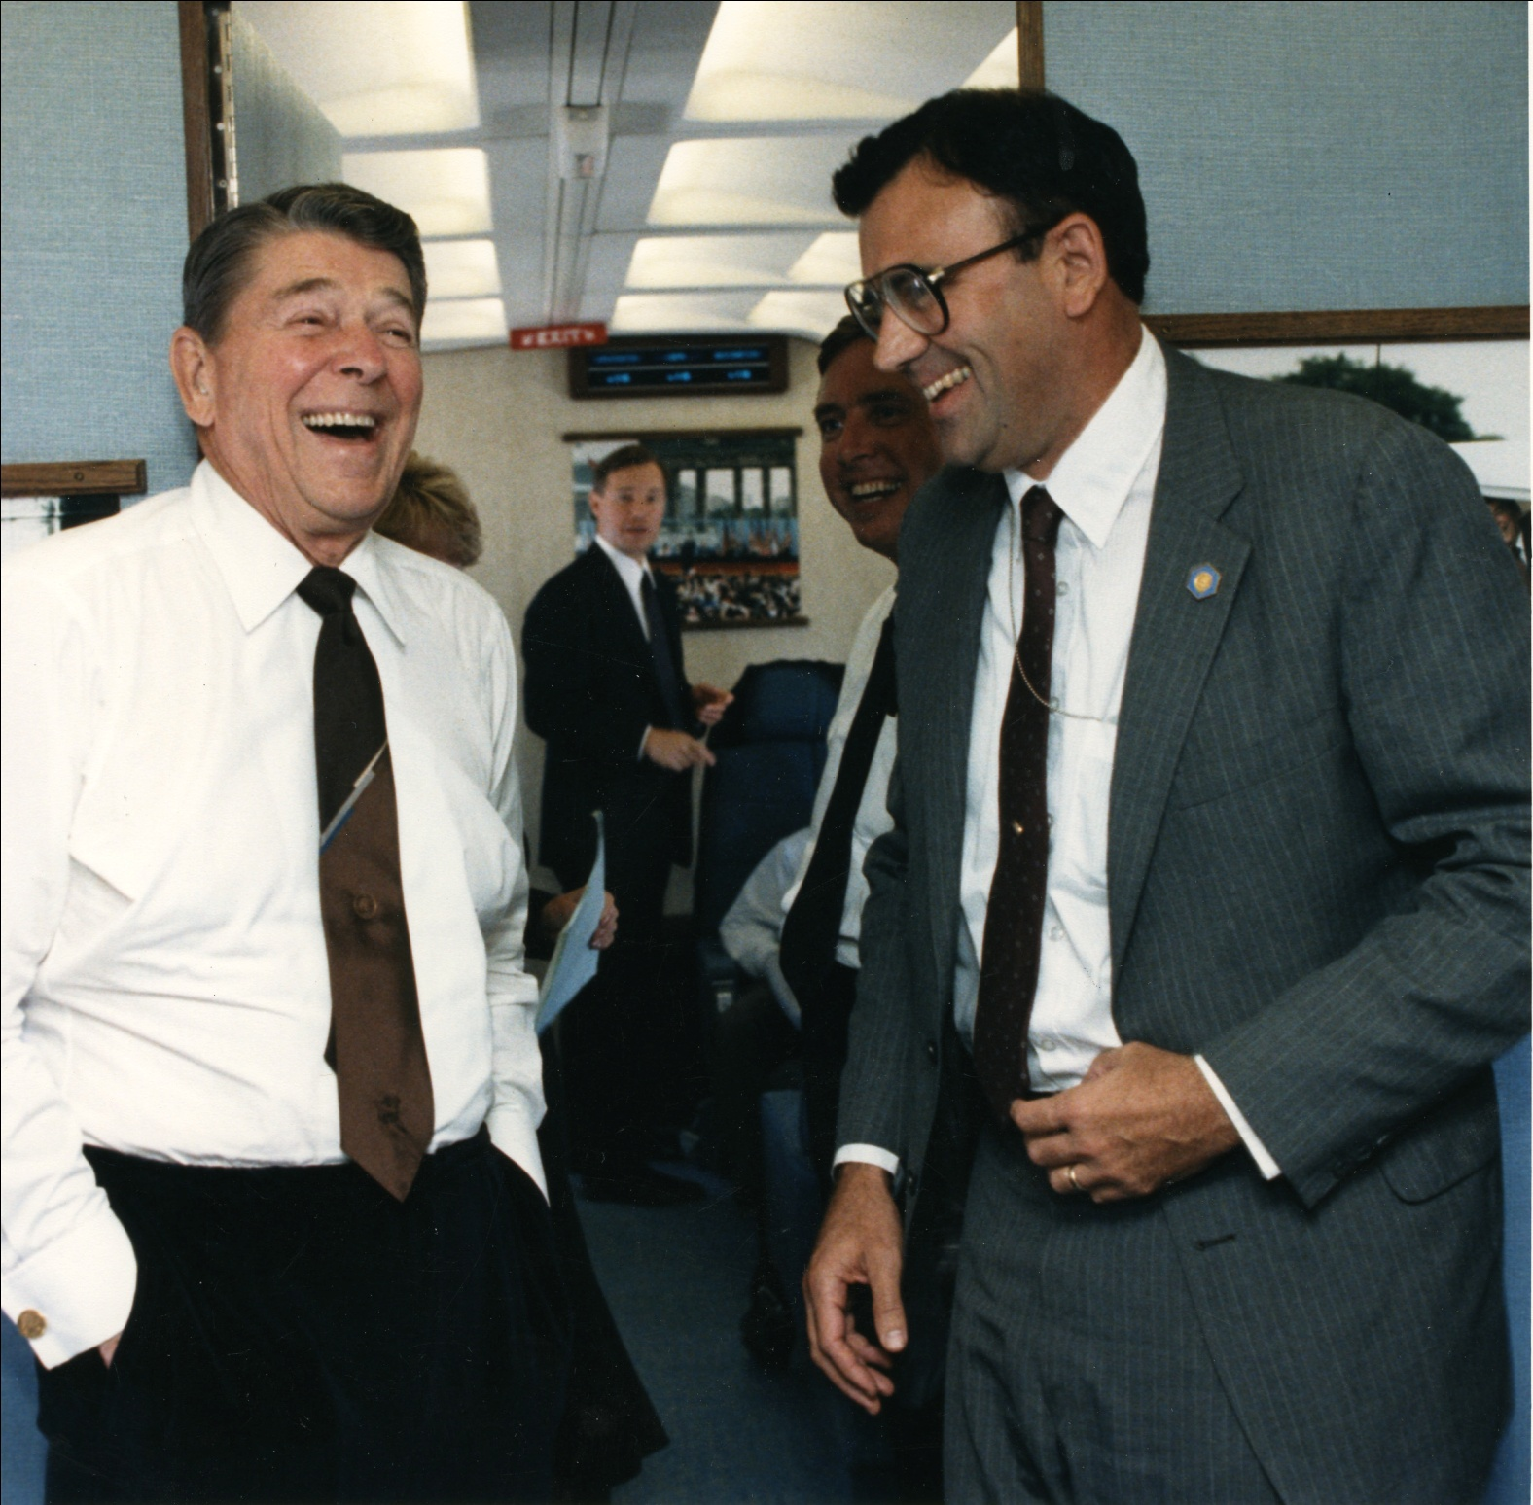
Reagan and his staff arrived in Switzerland two days in advance so that the President could become acclimated to the time difference. It also provided an opportunity to hold a courtesy meeting with the President of the host country, Kurt Furgler. In this session, I was struck by the somewhat condescending attitude of Furgler, who epitomized the European aristocracy at the time. He seemed to perceive Reagan as a B-rated movie actor who was somehow vaulted into the American presidency. He was, as were many Europeans, very hostile to Reagan’s SDI program in particular. During the discussions, Furgler looked across the table and somewhat sarcastically asked Reagan to describe “this fantasy idea of SDI that is going to upset the delicate balance that has enabled peace for so many years.” Clearly Furgler was enamored of the prevailing concept of “Mutual Assured Destruction,” or “MAD” for short, the doctrine that supposedly kept the peace because of the fear of mutual annihilation if a nuclear war ensured.
With the President on Air Force One en route to Geneva. He certainly was more relaxed than we were!

I think most of us in the meeting, particularly Secretary George Shultz and National Security Advisor Bud McFarlane, were taken aback by this supercilious statement. It certainly did not bother Reagan, who without a moment’s hesitation, responded:

“Mr. President, I come to this city of Geneva where some 35 years earlier the nations of the world gathered to outlaw the most inhumane aspects of war. I now come here as the leader of one of the two superpowers, two mighty countries who base their security on the threat of annihilating each other’s population! Mr. President, I have to think there is a better way to provide for our security. Don’t you?”

I observed the stunned expressions of Furgler and his colleagues in the room, who had not viewed the purpose of SDI in this way. It was incredibly hard for me and the other members of Reagan’s team to refrain from laughing. I mean, what was Furgler going to say, “Oh, no, we love the idea of destroying civilization as we know it to preserve global security?”

I would argue that this confrontation would set the tone for the Summit meeting; it certainly gave those of us in that meeting the confidence that Reagan would be able to justify and defend his ideals to anyone who challenged them....including Gorbachev!

The Geneva Summit

In this, his first meeting with a Soviet leader, the President would play host, that being diplomatic protocol—Reagan was both Head of State and Head of Government. In many countries that first role is symbolic, for example the Queen of England or the Presidents of Italy or Germany. The Head of Government function is generally performed by Prime Ministers, where real power lay (e.g., in the United Kingdom). Gorbachev, prior to the Summit, was only the General Secretary of the Communist Party and held no government position. That is, until just before the Summit we received word that Gorby had just been named as the Soviet “President!”

For that reason, Gorbachev, junior in protocol given Reagan’s time as head of State, came to the U.S. President’s residence in Geneva, the “Fleur D’eau”, for the initial meeting. It was a bitter cold November morning, but the skies were a clear, vibrant blue. Gorbachev drove up in his massive Soviet “Chaika” limousine, which looked something like a tank on wheels. He exited the car wearing a very heavy overcoat, an oversized fur hat, and a scarf wrapped around his neck, and waved to the crowd as he moved toward the house. The door of the mansion opened and out bounced Reagan, wearing only a dark blue suit and a broad smile. He scampered down the steps and extended his hand to Gorby, still wrapped up in his winter protective gear! That initial encounter not only set the tone for the Summit but also put to rest much of the background chatter in Europe contrasting the “aging” American President with the youthful, vibrant “GenSec”! We all looked at each other and commented, “The President’s got it!” Reagan, then, had the psychological advantage and kept it throughout the Summit.

At the outset, Reagan surprised Gorbachev by suggesting a private one-on-one meeting prior to sitting down at the plenary sessions. After some perfunctory exchanges, Reagan turned to Gorbachev and said, “Mr. General Secretary, you and I and our delegations are planning on just sitting here reading each other our prescribed talking points. We don’t really know each other. I have an idea—let’s just you and I and no one else (except translators) go down to the dacha here by the lake, and just chat and get to know each other better”? Gorby was a bit surprised, but agreed to do so.

I was with the advance team in the dacha waiting for the signal, as we had known that Reagan was going to make this suggestion. If Gorby accepted, then we were to start the fire in the dacha and have it going by the time the two leaders came down the steps toward the lake. All went well until a breeze came up, causing the curtains to drift into the fireplace—and they caught on fire! We grabbed the drapes and were taking them out the back, with a couple of my companions waving frantically to the President to slow down...until we got the smoke out of the room! Reagan caught on and pretended to exchange thoughts with Gorby for a few minutes on the steps. Of course the world’s press was gathered watching and recording all this, not knowing what was going on in the dacha. Just as the two leaders came into the room we were going out the back with the burned drapes, trying to blow the remaining smoke out.

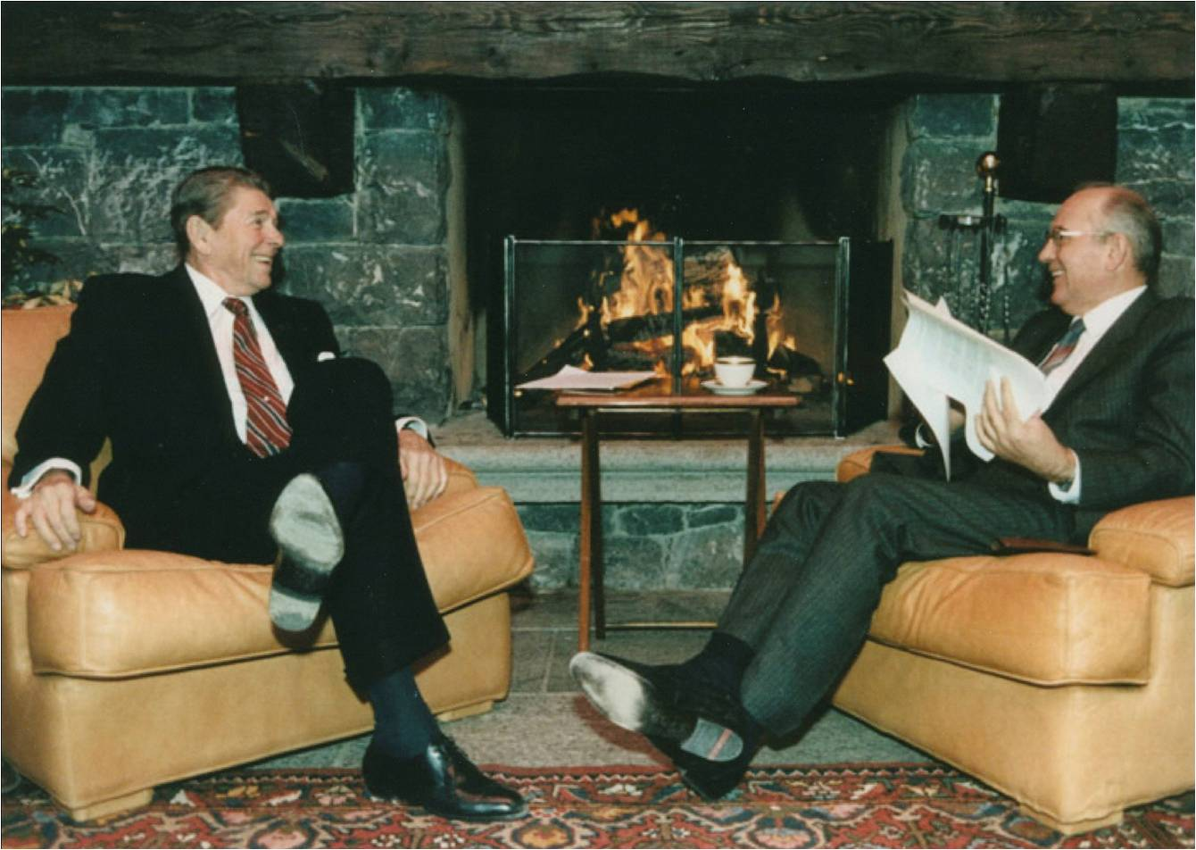

The informal session in the dacha worked wonderfully, and it served to break the ice and allow the two superpower leaders to chat informally before getting back to the intensiveness of the Summit negotiations.

In his memoirs, Reagan mused on the fireside chat: “Here we were”, he wrote, “...the two of us...in a unique situation. Here we were, I said, two men who had been born in obscure rural hamlets in the middle of our respective countries, each of us poor and from humble beginnings. Now we were the leaders of our countries...and probably the only two men in the world who could bring about World War III”. (Reagan, p. 636)

Secretary Shultz noted that after the fireside chat that he felt the dynamics of the Summit were changing. For example, he said that Nancy Reagan had orchestrated a wonderful dinner the first night.... and “both Reagan and Gorbachev were relaxed. They spoke with warmth in their toasts at the dinner table” (Shultz, page 604).

The meetings and negotiations themselves were marked by three days of intensive, candid exchanges of views, difficult negotiations, near collapses of the Summit, and in the end, a historic agreement between two entrenched adversaries. Although the negotiations were difficult and protracted, and Gorbachev proved to be as intelligent, knowledgeable and facile as we had anticipated, Reagan held firm to his principles. No more unverifiable treaties (“Trust but Verify” he loved to say in Russian), no more agreements codifying Soviet superiority in arms on the European continent, no more tolerating Moscow’s refusal to grant its citizens basic human rights, and—perhaps most importantly to the President—no more reliance on offensive nuclear weapons to provide for our security.

Many times during the three days of the Summit it appeared that the negotiations would collapse. A failure would reinforce the image of Reagan as an aging cowboy-actor, unable to reach an agreement with the reform-minded Soviet leader. But Reagan still would not compromise on his deep felt desire to shift away from a dependence on the threat of annihilating each others’ populations as a basis for maintaining our security.

Gorbachev, too, hung firm, hoping that the President would “understand” that an agreement on Moscow’s terms would ensure that the President emerged from the Summit as a popular and respected world leader and peacemaker.

It was not only the U.S. team that was seriously split over policy issues. Shultz notes that the divisions within the Soviet side were equally vehement. The Secretary pinpointed Deputy Foreign Minister Georgy Kornienko as the primary obstacle on the Soviet team. At the dinner hosted by the Reagans, Shultz finally had enough and said he flew off the handle at Kornienko’s obstructionist tactics and constant revisions of the draft agreement. “I accused Kornienko of trying to prevent the General Secretary’s approach to the agreed statement from being carried out.....Reagan and Gorbachev both were surprised by my suddenly explosive demeanor” (Shultz, p.605).... Apparently it worked, according to George, because Gorbachev then scolded Kornienko, saying, “We don’t go back on our agreements”!

In the end, Gorbachev conceded on several key negotiating points, particularly relating to SDI, because he was aware of the deteriorating state of the Soviet economy and Moscow's inability to keep pace with American military and technological advances.

In the communiqué that was agreed on following the meeting the Soviet Union and United States agreed to advance toward a 50% reduction in nuclear weapons. As Bud McFarlane recently wrote to me, “this was the first time in the history of arms control that the Soviets had signed on to the very idea of reductions. It truly was the beginning of the end”.

The Summit agreement was a signal triumph for Reagan. As the New York Times acknowledged, Reagan, “in great part through his own powers of leadership” was subsequently able to deliver “a historic series of agreements with Mikhail Gorbachev that led to the peaceful dismantling of the Soviet empire.” Within seven years, the Warsaw Pact dissolved, Germany was reunited and joined NATO, and, finally, the USSR itself disappeared.

Ronald Reagan’s diplomacy and negotiating skills set the stage for the eventual end of the Cold War on our terms, an outcome that began that day in Geneva in 1985. In my opinion, the successful summit in effect signaled the beginning of the end of forty years of the Cold War.

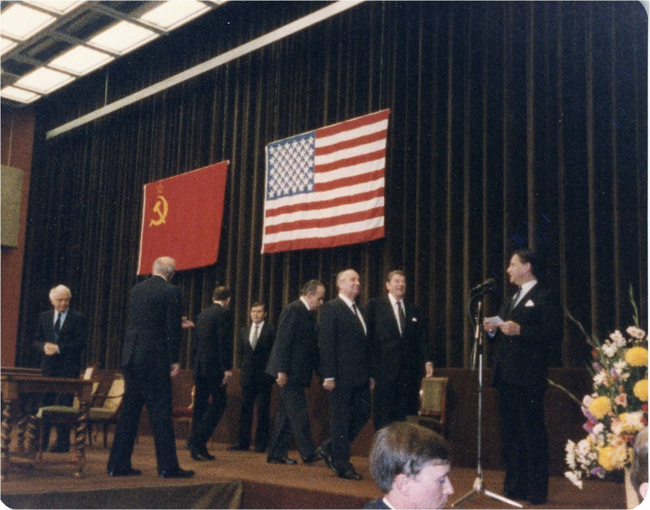

Reagan and Gorbachev at the signing ceremony, culminating the Geneva Summit.

//////////////

I just wanted to add a personal perspective of what it was like in our operations center that final night in Geneva.

The negotiations and discussions between Reagan and Gorbachev extended far into the night, much longer than anyone had anticipated. Despite this, events slated for the next day were "still on track," including a presumed Reagan/Gorbachev final appearance at the Summit and a document-signing (if any), Reagan's flight on Air Force One to Brussels where he would deliver a summary of the Summit to NATO leaders, and then his return to Washington to address Congress on the accomplishments (if any!) of the Geneva Summit.

Of course, this meant that final speeches for the President had to be drafted for the concluding event of the Summit, as well as the two major speeches in Brussels and Washington. I was the principle drafter of the President's remarks to NATO, but our key staffers were focused on the President's historic address to Congress, including Ambassador Jack Matlock, Chief Speech Writer Peggy Noonan, et al. All of this speech drafting was being conducted while the negotiations continued and none of us had any idea as to whether the Summit was going to be a success or failure. Indeed, some thought that Gorbachev could score more points by simply walking out of Geneva, complaining that he "could not deal with this stubborn, old cowboy." And, remember that since we had to have everything packed and ready to leave early the next morning, the Advance Team was already gathering up our electronic typewriters and other equipment (remember this was really in the pre-computer age).

About 9:30 pm, I got a call from Colonel Bob Linhard, who was at the negotiations. Bob indicated that "Gorby had just caved on a key point relating to SDI" and prospects for a successful summit were looking up. About a half hour later, Linhard called again to say that Gorbachev had fallen off another demand and that we should write the remarks and speeches describing a very successful summit!

So we did! I was working essentially alone, trying to keep at least one electric typewriter that I and one secretary could use to complete the President's speech at NATO. We did that just before midnight and got the draft to the President for his review!

Amazingly Reagan and Gorbachev's remarks concluding the Summit went very well the next morning, as did the President's report to NATO and his speech to the US Congress, where he received an overwhelming ovation later that night.

After the President gave his talk in Brussels and went on to Washington, I collapsed there in Belgium and slept for the next twelve hours straight.
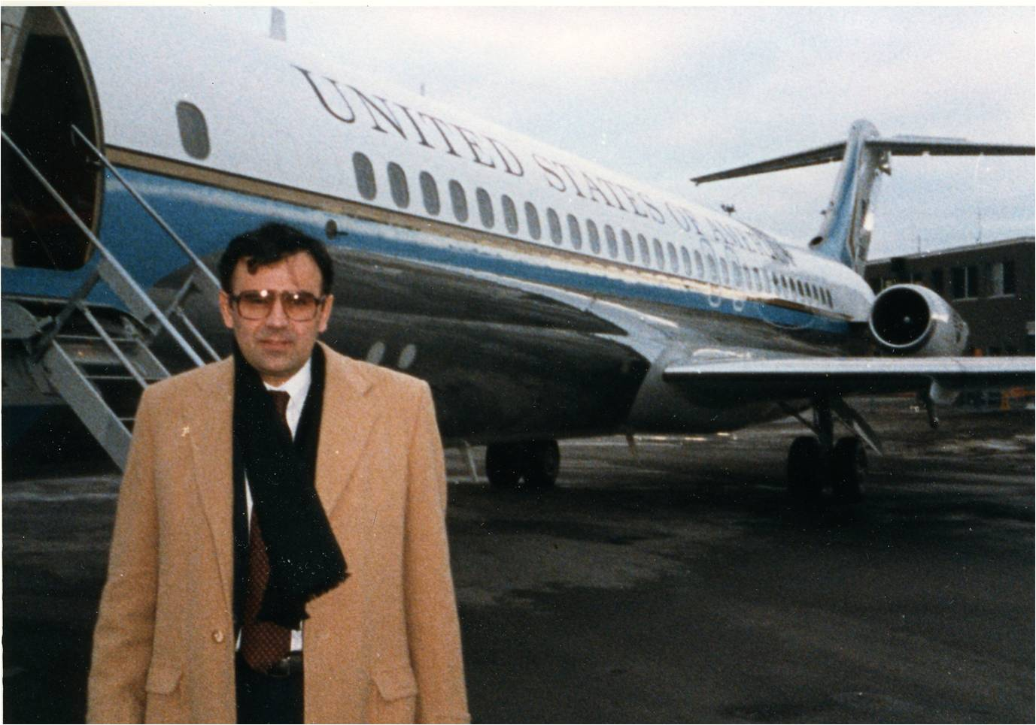
In Brussels on Air Force One after the Summit and the President’s speech to NATO. Totally wiped out!

The Significance of the Summit

I think President Reagan summed up the significance of the Geneva Summit quite well in his address to Congress:

“I can’t claim that we (he and Gorbachev) had a meeting of the minds on such fundamentals as ideology or national purpose....but we understand each other better and that’s a key to peace....we have a long way to go, but we’re heading in the right direction” (Reagan, p. 641).

